int sensorPin = A0;
int sensorValue = 0;
void setup() {
Serial.begin(9600);
}
void loop() {
sensorValue = analogRead(sensorPin);
Serial.println(sensorValue);
delay(100);
}
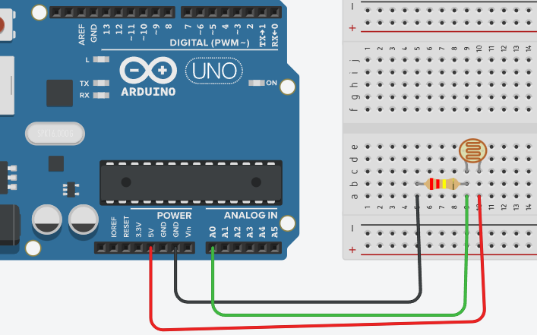
Component Connection
LDR one end 5V
LDR other end A0 +
resistor
Resistor other
end GND

